Comparing Hyperconverged infrastructure solutions: Harvester and OpenStack

# Introduction

The effectiveness of a good resource management in a secure and agile way is a challenge today, there are several solutions like Openstack and Harvester who handles your hardware infrastructure as an on-premise cloud infrastructure allowing the management of storage, compute and networking resources in a more flexible way than deploying applications on a single hardware only.

Both Openstack and Harvester have their own use cases. This article describes architecture, components and differences between them to clarify what could be the best solution for every requirement.

This post analyzes the differences between OpenStack and Harvester from different perspectives: infrastructure management, resource management, deployment and availability.

Cloud management is about how to manage datacenter resources (storage, compute and networking), Openstack provides a way to manage these resources and provides a dashboard for administrators to handle the creation of virtual machines and other management tools for networking and storage layers.

While both Harvester and OpenStack are used to create cloud environments, there are several differences I will talk about.

According to the product documentation, [OpenStack](https://docs.openstack.org/yoga/) is a cloud operating system that controls large pools of compute, storage and networking resources throughout a datacenter, all managed through a dashboard that gives administrators control while empowering their users to provision resources through a web interface.

|  |
| --- |
| *OpenStack* |

Harvester uses [KubeVirt technology](https://kubevirt.io/) to provide cloud management with the advantages of Kubernetes. It helps operators consolidate and simplify their virtual machine workloads alongside Kubernetes clusters. Harvester is the next generation of open source hyperconverged infrastructure (HCI) solutions designed for modern cloud native environments.

## Architecture

While OpenStack provides its own services to create control planes and configures the infrastructure provided, Harvester uses the following technologies to provide the required stacks:

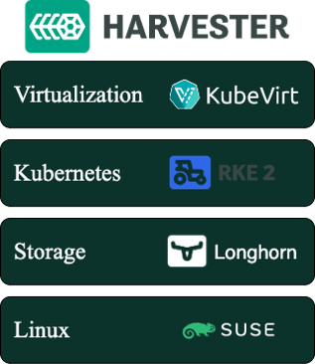

Harvester is installed as a node operating system using an ISO or a PXE-based installation, it uses **RKE2 as container orchestrator on top of SUSE Linux Enterprise Server to provide** **distributed storage with Longhorn and virtualization with KubeVirt.**

## APIs

Whether your environment is in production or in a lab setting, API use is far reaching — for programmatic interactions, automations and new implementations.

Openstack, throughout each of its services, provides several APIs for its own functionality and to provide storage, management, authentication and many other features externally. As per the [documentation](https://docs.openstack.org/install-guide/get-started-logical-architecture.html) The logical architecture gives an overview of the API implementation.

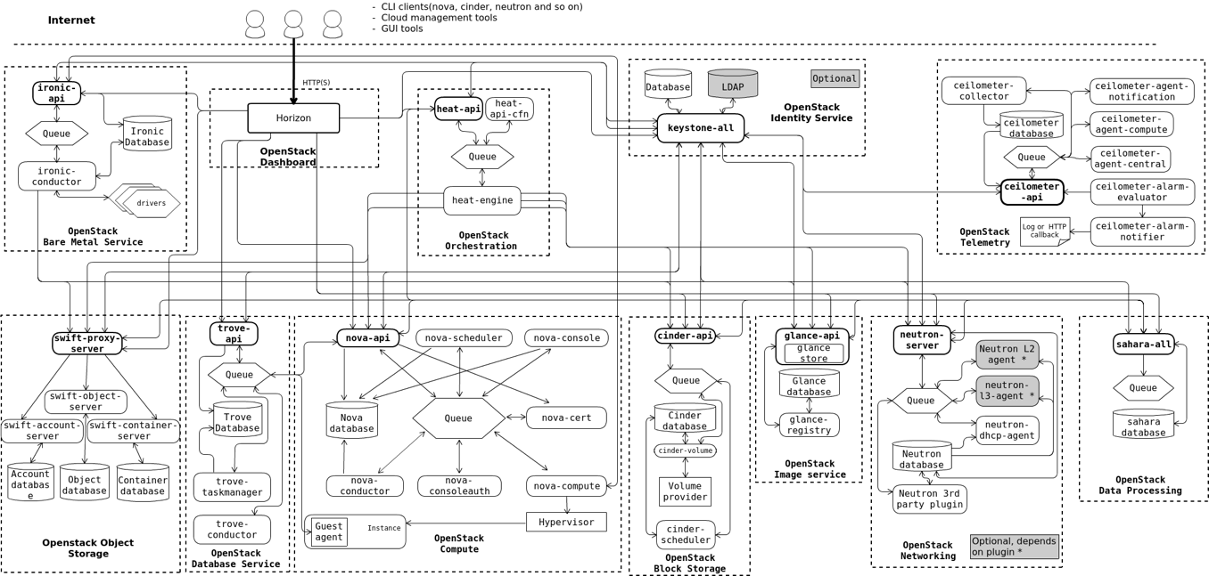

In the diagram above you can see in **bold** the APIs a productive Openstack provides.

Although OpenStack can be complex, it allows a high level of customization.

Harvester, in the meantime, uses Kubernetes for virtualization and Longhorn to storage, taking advantage of their APIs and allowing a high level of customization from the containerized architecture perspective. It can also be extended through the K8s *CustomResourceDefinitions,* expanded and migrated easily.

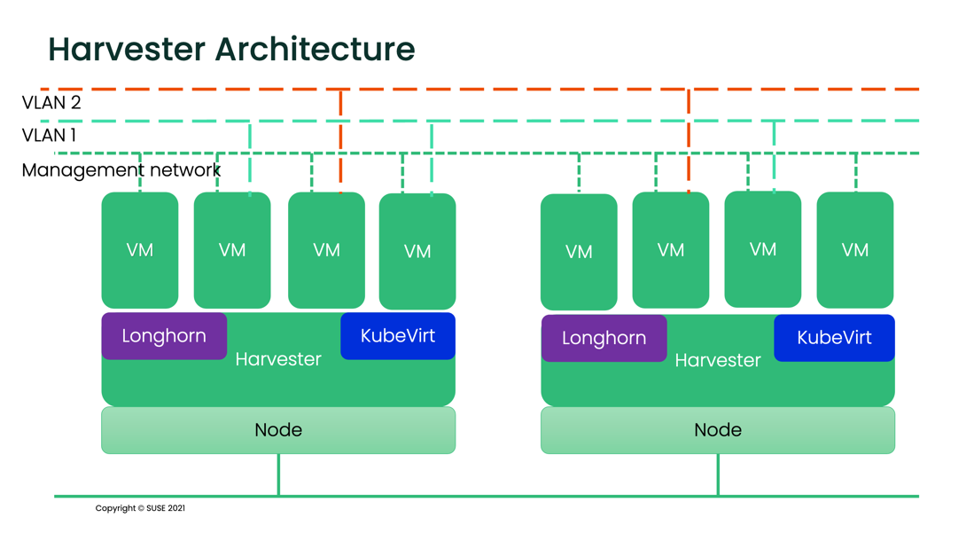

At networking level, Harvester supports VLAN through bridges and NIC bounding only. Switches and advanced network configurations are outside the scope of Harvester.

OpenStack can provide multiple networking for advanced and specialized configurations.

## Deployment

OpenStack provides several services on bare metal servers: installing packages and libraries, configuring files and preparing servers to be added to OpenStack.

Harvester provides an ISO image preconfigured to be installed on bare metal servers.

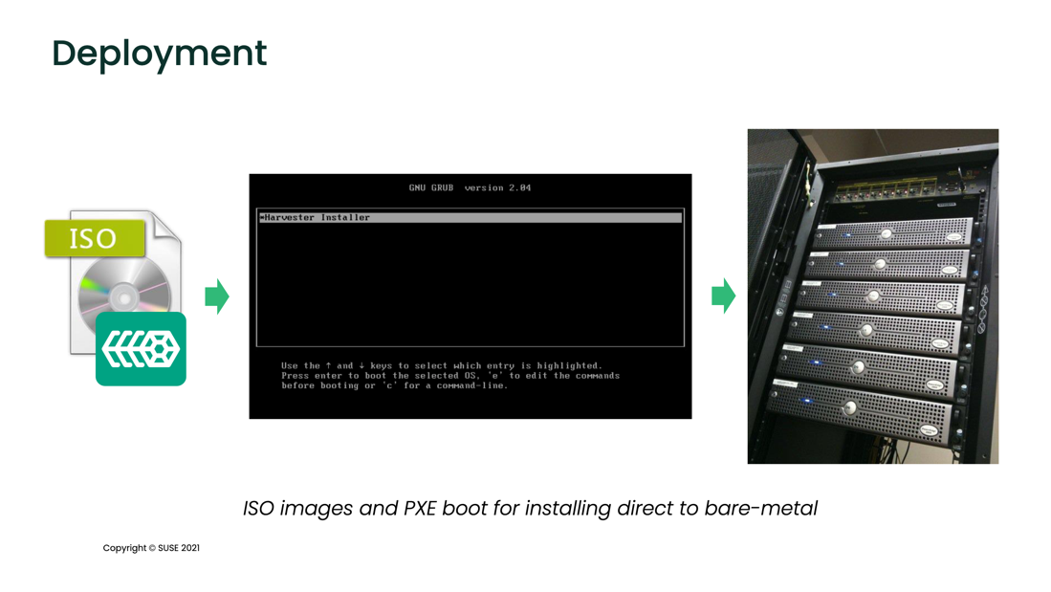

Just install or pxe-install the image and the node will be ready to join the cluster which also adds flexibility to scale nodes quickly and securely as needed

# Node types

OpenStack’s minimum architecture requirements consist of two nodes, one controller node to manage the resources and provide the required APIs and services to the environment and another compute node to host the resources created by the administrator.

To be supported in a production architecture, the controller nodes will maintain their roles.

Harvester nodes are interchangeable. It can be deployed in all-in-one mode, and the same node serving as controller will serve as compute node. This makes Harvester a good choice to consider for Edge architectures.

# Cluster management

Harvester is fully integrated with Rancher, which makes it easy to add and remove nodes. There is no need to preconfigure new compute nodes or handle the workloads -- Rancher manages the cluster management.

Harvester can start in a single node (also known as all-in-one), where the node serves as a compute and a single node control plane. Longhorn, deployed as part of Harvester, provides the storage layer. When the cluster reaches three nodes, Harvester will reconfigure itself to provide High Availability features without disruption; the nodes can be promoted to control plane or demoted as needed.

In OpenStack, roles (compute, controller, etc.) are locked since the node is being prepared to be added to the cluster.

# Operations

To handle the operation, Harvester leverage Rancher for authentication, authorization and cluster management.

Harvester integration with Rancher provides an intuitive dashboard UI where you can manage both layers: Rancher and Harvester all in one.

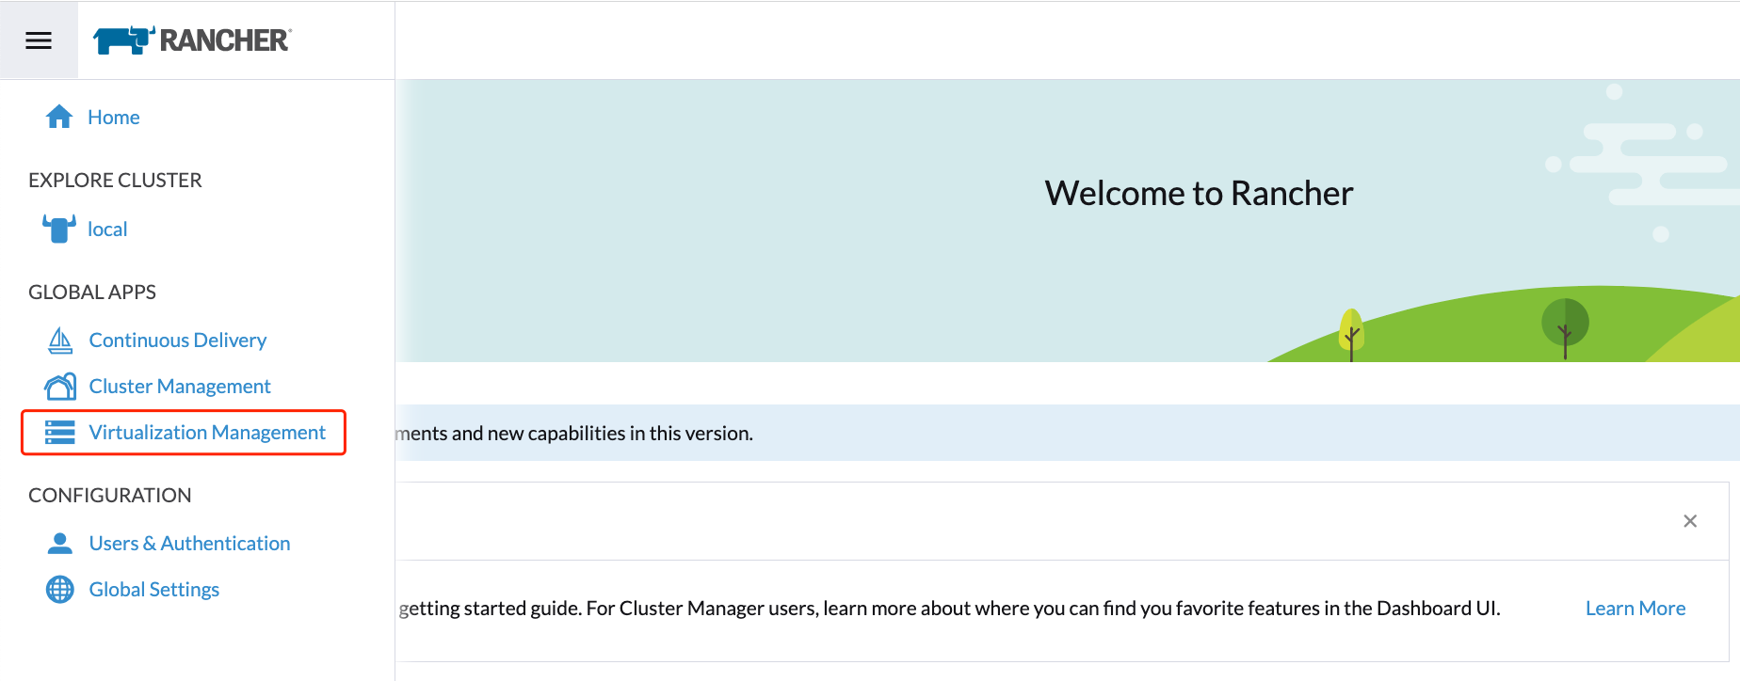

Harvester also provides monitoring, managed with Rancher, since the beginning. Users will see the metrics on the dashboard.

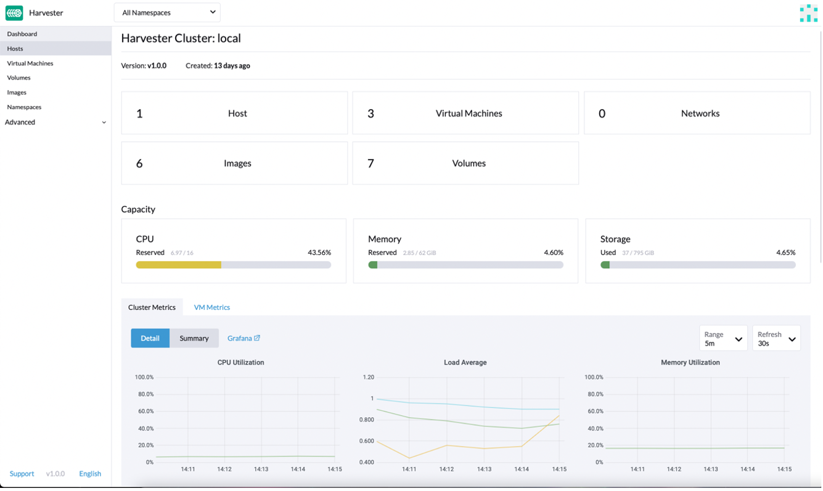

Providing a single source of truth to the full environment.

## Storage

In Harvester, storage is provided by Longhorn as a service running on the compute nodes, so Longhorn scales easily with the rest of the cluster as new nodes are added.

There is no need for extra nodes for storage.

Also, there is no need to have external storage controllers to communicate between control plane, compute and storage nodes.

Storage is distributed along the Harvester nodes, from the point of view of the VMs. There is no local storage.

Storage in Harvester supports backup to NFS or S3 buckets.

# Conclusion

Harvester is a modern, powerful cloud-based HCI solution based on Kubernetes and fully integrated with Rancher that eases the deployment, scalability and operations.

While Harvester only supports NIC bounding and VLAN (bridge) methods, more networking modes will be added.

For more specialized **network** configurations, OpenStack is the preferred choice.

# Want to know more?

Check out the resources!

* [Harvester Product Page](https://www.suse.com/products/harvester/)
* [Getting Hands on with Harvester HCI](https://www.suse.com/c/rancher_blog/getting-hands-on-with-harvester-hci/)

**Harvester** is open source -- if you want to contribute or check what is going on, visit the [Harvester github repository](https://github.com/harvester/harvester)